

**Digital Signal Processing Project Report**

Project Title:

**“Digital Hearing Aid”** Submitted by:

**Hamza Ikram (2020-CE-06)**

**Talha Arfan (2020-CE-15)** Submitted to:

**Ma’am Sahar Waqar**

Course:

**CMPE-371: Digital Signal Processing**

Semester:

**6th Semester**

Date:

**23rd May 2023**

**Department of Computer Engineering**

**University of Engineering and Technology, Lahore**

Table of Contents

1.Abstract: 3

2. Introduction: 3

3. Project Overview: 3

4. Problem Statement: 4

5. Objectives: 4

6. Literature Review: 5

7. Hearing Loss and Its Impact: 5

8. Need of Hearing Aid: 6

9. Traditional Hearing Aid Technologies: 7

10. Digital Signal Processing in Hearing Aids: 8

11. Explanation: 8

12. Block Diagram: 10

13. Algorithm: 11

14. Requirements: 12

15. Implementation: 12

a. Noise Addition 12

b. Noise Reduction Filter 13

c. Frequency Shaper 13

d. Amplitude Compression 13

16. GUI and Program Flow: 13

17. Responses for Sample File: 18

18. Challenges Faced: 21

19. Conclusion: 22

20. References: 22

# Abstract:

This project focuses on the development of a digital hearing aid. The main aim of this project is to design a system that can amplify sound signals to improve speech recognition and clarity for people with moderate to severe hearing loss. The hearing aid system proposed consists of several stages, including a pre-processing stage to eliminate background noise and enhance speech signals, a filtering stage to remove unwanted signals, and a frequency compression stage to amplify higher frequencies.

Overall, the proposed digital hearing aid system has the potential to enhance the quality of life for people with hearing loss by providing an effective and affordable solution to improve their hearing ability.

# 2. Introduction:

In a world where the ability to hear is a vital part of our daily lives, hearing loss can severely impact a person's quality of life. Hearing aids have evolved over the years, but the recent advancements in digital signal processing (DSP) have revolutionized the way we design and implement hearing aids.

The digital hearing aid is a sophisticated and advanced device that uses DSP techniques to improve the quality of sound that is transmitted to the hearing-impaired individual. These devices are designed with the latest signal processing technologies that allow for a more accurate and customized sound amplification process. DSP technology provides the ability to reduce background noise while simultaneously enhancing speech clarity, making it easier for individuals with hearing loss to communicate effectively in various environments.

This project holds great significance for people living with hearing loss and offers the possibility of significantly improving their quality of life.

# 3. Project Overview:

Digital Signal Processing (DSP) technologies have revolutionized the hearing aid industry by offering comprehensive digital hearing solutions to people experiencing hearing loss. The digital hearing aid project aims to provide a Signal Processing technology that improves audio fidelity and clarity and ensures hearing comfort for people suffering from hearing impairments.

The primary goal of this project is to develop a digital signal processor that provides users with enhanced audio clarity and the ability to customize their hearing experience.

The signal processing algorithms will provide users with a range of features such as adaptability to various environments, noise reduction, and speech enhancement.

This project digital hearing aid will be designed with user-friendly controls and interfaces.

In conclusion, the DSP project digital hearing aid system offers sophisticated signal processing technologies that aim to improve audio comfort and quality for people suffering from hearing loss. The system aims to provide users with an advanced, customizable, and discreet solution that enables them to hear sounds with utmost clarity and comfort even in noisy environments. The device will undergo testing and quality control checks before it hits the market, ensuring user safety and satisfaction.

# 4. Problem Statement:

# The goal of this project is to design and develop a digital signal processing algorithm that can enhance the sound quality and intelligibility of speech for individuals with hearing impairments. The current analog hearing aids are limited in their ability to filter out unwanted noise and amplify specific frequency ranges, resulting in reduced speech comprehension and limited ability to participate in daily activities.

# 5. Objectives:

The primary objective of the DSP project digital hearing aid is to design and develop a high-quality digital hearing aid that can provide enhanced hearing clarity and reduce background noise for individuals with hearing impairments.

The detailed project objectives are as follows:

* To conduct a thorough analysis of the current hearing aid market to identify the latest digital signal processing (DSP) technologies and trends.
* To design a digital signal processing algorithm that can provide clear and accurate sound reproduction while minimizing background noise.
* To select and optimize the appropriate amplification.
* To develop a user-friendly interface for the hearing aid.
* To establish partnerships with audiologists and healthcare providers to distribute and promote the hearing aid and provide maintenance and support services.
* To continuously monitor and improve the hearing aid's performance and user feedback to address any issues or suggestions for enhancement.

Overall, the DSP project digital hearing aid aims to improve the quality of life and social participation of individuals with hearing loss by providing a reliable and affordable solution for better hearing health.

# 6. Literature Review:

Some studies have shown that digital hearing aids may provide better speech intelligibility and sound quality compared to traditional analog hearing aids. This is since digital hearing aids can process sound more accurately, resulting in a more natural sound quality for the user. They are also able to provide a wider range of amplification, which can be particularly important for those with severe hearing loss.

A review of literature shows that DSP hearing aids have a wide range of features that can be tailored to the specific needs of the wearer. Some of the key features include noise reduction, feedback reduction, automatic volume control, and directional microphones. Studies have shown that DSP hearing aids provide improved speech intelligibility, reduced listening effort, and improved listening comfort compared to analog hearing aids.

In addition, DSP hearing aids can be programmed remotely using wireless technology, allowing audiologists to fine-tune the hearing aid without the need for in-person visits. This has made hearing aid fitting more accessible to people in remote areas.

Furthermore, research has shown that DSP hearing aid technology can be integrated with other technologies such as Bluetooth (BLE), allowing users to stream audio from smartphones, televisions, and other devices directly to their hearing aids.

# 7. Hearing Loss and Its Impact:

Hearing loss can range from mild to profound and can impact individuals in different ways. Some common types of hearing loss and their potential impact on the effectiveness of a digital hearing aid are:

**1. Sensorineural hearing loss:**

This type of hearing loss occurs due to damage to the inner ear or the nerve pathways that transmit sound signals to the brain. People with this type of hearing loss may have difficulty understanding speech or hearing certain sounds. Digital hearing aids can help amplify sounds and improve understanding but may not be able to fully restore hearing.

**2. Conductive hearing loss:**

This type of hearing loss occurs due to a blockage or damage to the outer or middle ear, preventing sound from reaching the inner ear. People with this type of hearing loss may have difficulty hearing soft sounds and may experience a muffled or distorted sound. Digital hearing aids can help amplify sounds and improve clarity but may not be effective if the blockage is severe.

**3. Mixed hearing loss:**

This type of hearing loss is a combination of both sensorineural and conductive hearing loss. People with this type of hearing loss may experience a combination of the symptoms described above. Digital hearing aids may be able to improve hearing to some extent, but the effectiveness will depend on the severity and cause of the hearing loss.

The impact of hearing loss on the use of a digital hearing aid can vary from person to person. Some potential challenges include difficulty hearing in noisy environments, and discomfort from wearing the device. However, with proper fitting and adjustment, digital hearing aids can greatly improve a person's ability to hear and communicate, enhancing their overall quality of life.

# 8. Need of Hearing Aid:

Hearing aids play a crucial role in digital hearing projects of DSP (Digital Signal Processing) as they help individuals with hearing loss to amplify sounds and understand speech better. Digital hearing aids use advanced signal processing technology to enhance and clarify sounds in different environments, which can significantly improve the hearing experience for users. The right hearing aid can also help individuals to participate more fully in social activities, which can improve their overall quality of life. Therefore, hearing aids are an essential component of digital hearing projects. Here are some degree levels of hearing loss of humans.

# 

# 9. Traditional Hearing Aid Technologies:

Some traditional hearing aid technologies are described as follows:

* **Analog hearing aids:**

These were one of the earliest forms of hearing aids, where sound is amplified without any processing or distortion. They work by converting sound waves into electrical signals and amplifying them to the ear.

* **Digital signal processing (DSP) hearing aids:**

These hearing aids use digital technology to process sound signals, including filtering out background noise and enhancing speech. DSP hearing aids typically have features like noise reduction, feedback cancellation, and automatic volume control.

# Bluetooth-enabled hearing aids:

These hearing aids have Bluetooth connectivity features that allow you to easily stream audio directly from your smartphone, TV, and other compatible devices.

# 10. Digital Signal Processing in Hearing Aids:

Digital signal processing (DSP) algorithms provides:

* **Advanced noise reduction:**

DSP technology allows hearing aids to reduce background noise and focus on speech signals, making it easier for users to understand conversations in noisy environments.

* **Feedback cancellation:**

Feedback is a distracting and annoying sound that is often heard with hearing aids. Advanced DSP hearing aids provides feedback cancellation to eliminate this annoying sound.

* **Personalized sound tuning:**

DSP hearing aids can be customized to the specific hearing needs of everyone, making it easier for users to hear the sounds they need to without being overwhelmed by background noise.

* **Digital streaming capabilities:**

Many modern hearing aids are equipped with Bluetooth technology that enables them to connect wirelessly to various devices like phones, TV, and music players, so users can stream audio directly to their hearing aids.

* **Remote programming:**

DSP hearing aids enable remote programming where audiologists can adjust the hearing aid settings without the patient having to visit the clinic. This is a convenient method for patients who live in remote areas or have mobility issues.

# 11. Explanation:

A digital hearing aid is an electronic device that uses digital signal processing (DSP) to amplify sound for people with hearing impairments. The project of building a digital hearing aid involves designing and implementing various algorithms for processing sound signals, such as filtering to improve the quality and clarity of sound for the user.

The first step in the development of a digital hearing aid project is the design of the hardware components (optional), including the microphone, amplifier, DSP chip, and speaker. The microphone is used to capture sound signals, which are then amplified by the amplifier and processed by the DSP chip. The processed signal is then sent to the speaker, which delivers the amplified sound to the user's ear.

The next step in the project is the implementation of DSP algorithms for processing the sound signal. The goal of these algorithms is to improve the sound quality and clarity for the user.

The key algorithm used in digital hearing aids is:

**Noise Reduction**, which filters out background noise and enhances speech frequencies.

Another important algorithm is **Compression**, which adjusts the amplification level of the sound signal based on its frequency and amplitude.

To ensure that the digital hearing aid meets the specific needs of the user, the project also includes a user interface.

The development of a digital hearing aid project requires expertise in both hardware design and DSP algorithms. The project aims to deliver a system that improves the user's quality of life by enhancing their ability to hear and communicate.

Overall, the digital hearing aid is a remarkable technology that has significantly improved the quality of life for individuals with hearing loss. It is an excellent example of how DSP can be used to enhance an essential aspect of human life, making it easier for people to communicate, interact with others, and enjoy the world around them.

# 12. Block Diagram:

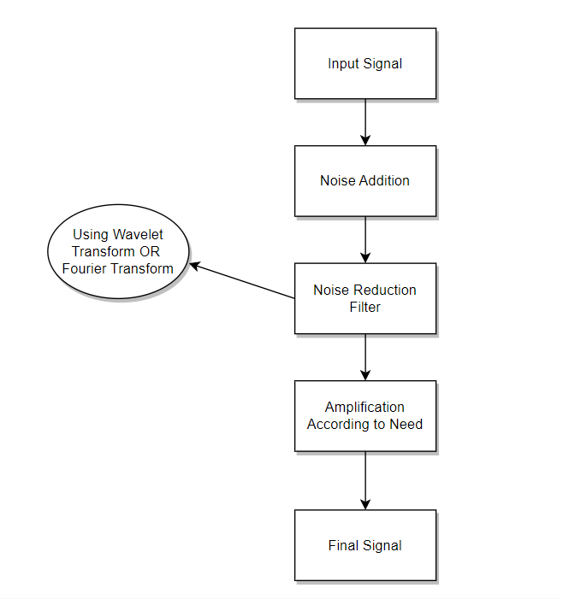

As we can see, first we have an input signal which can be of user record or any demo audio file then we remove noise from the audio as well as amplify the sound according to our needs. Means there is two processes which are:

* Noise Reduction
* Sound Amplification

# 13. Algorithm:

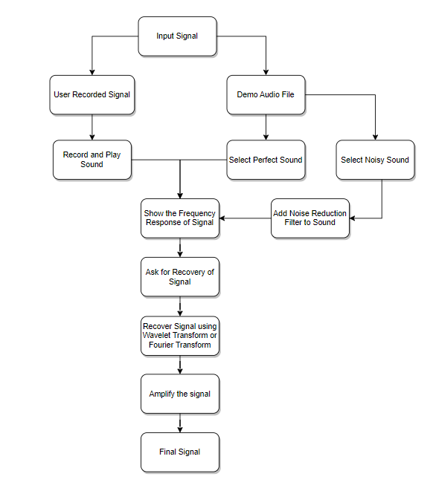

As we have input signal firstly, we use noise reduction filter (Wavelet Denoising) to remove all the unwanted noise from the audio then we will have to ask for the recovery of signal and we recover signal using **Fourier Transform** and **Wavelet Transform** then finally we have our final amplified sound according to our need.

# 14. Requirements:

To create a digital hearing aid system, there are several requirements needed to ensure that this is an effective system:

* **Noise Reduction Algorithm**:

It should include advanced noise reduction algorithms such as active noise cancellation or adaptive directional microphones, which help to reduce background noise for improved sound quality.

* **Amplification Algorithm**:

The hearing aid system should also have sophisticated amplification algorithms to ensure that the sound is loud enough and clear for the user to hear, without causing any feedback or distortion.

* **User interface**:

A user interface should be included to allow users to easily adjust the settings to their preferences.

# 15. Implementation:

As we have seen, the block diagram for the MATLAB implementation of Digital Hearing Aid System. The input speech signal takes the form of human

voice. The input speech signal will pass through several functions i.e., noise addition, noise reduction filter, frequency shaper and amplitude

compression before producing an adjusted output speech signal which is audible to the hearing-impaired person.

## **Noise Addition**

Since the input speech signal for this system is a clean signal, some noise is added to simulate a real situation. In this system, the Additive White Gaussian Noise (AWGN) and random noise are added to the input speech signal by using MATLAB function. The noise Additive White Gaussian Noise

(AWGN) has a continuous and uniform frequency spectrum over a specified frequency band and has equal power per Hertz of this band.

It consists of all frequencies at equal intensity and has a normal (Gaussian) probability density function [3].

## **Noise Reduction Filter**

A major anxiety for the people with hearing loss is the capability of hearing aid to differentiate intended speech signal in a noisy environment.

Hence, to eliminate the noise, a reduction filter function is used in this design. To suppress the noise in the signal, the wavelet filter function is used.

## **Frequency Shaper**

One major complaint of hearing aid users is that the hearing aid amplifies all signals rather than the significant signal that they desire to hear. Most hearing impaired has difficulties to hear high frequency signal. Therefore, the frequency shaper is designed to correct for loss of hearing at certain frequencies. It applies high gain for higher frequencies and vice versa.

## **Amplitude Compression**

Fundamentally, amplitude compression function is the task of controlling the overall gain of a speech amplification system. Amplitude

compression will ensure that the amplified signal will not exceed saturation power. Saturation power is where the sound signal begins to

become uncomfortable.

# 16. GUI and Program Flow:

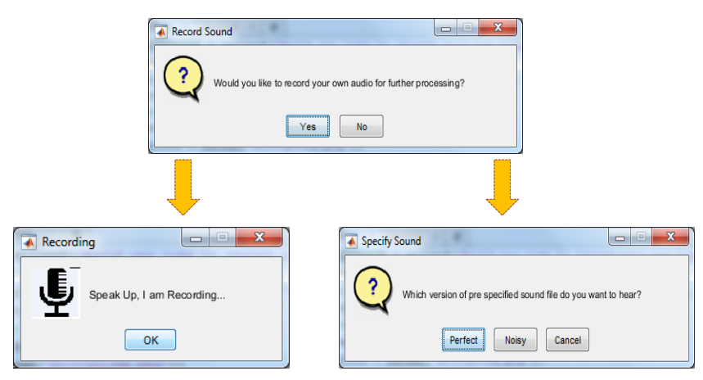

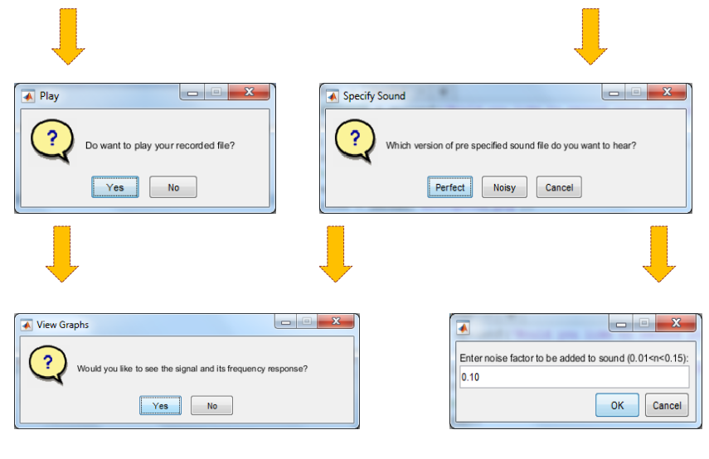

**The Spectrum of Audio Recorded**

**Recovering Signal i.e., Removing Noise**

**Amplification of Recovered Audio**

# 17. Responses for Sample File:

**The Perfect Sound**

**Addition of Noise in Signal**

**Recovery Using Wavelet Transform**

**For Normal Hearing**

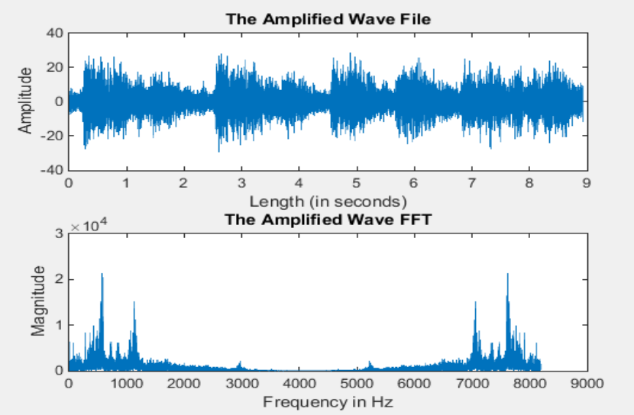

**For Hearing Loss of 30dB**

# 18. Challenges Faced:

The main challenges we faced during our project are:

1. **Signal Processing Issues**:

The main challenge in a DSP project to create a digital hearing aid is signal processing. The hearing aid must amplify the correct signals while suppressing specific frequencies of noise. Additionally, the amplification of the signals must be done without causing distortion to the original signal.

1. **Limited processing power of devices:**

Digital hearing aid devices have limited processing power. This is because of their size and the need to conserve battery life. Therefore, optimizing the algorithms for signal processing is essential to ensure that the final hearing aid device provides adequate amplification to the user.

1. **Accuracy:**

The accuracy of the signal processing algorithms is also a critical factor in making digital hearing aid devices. A slight error in the processing of the signals can result in inadequate amplification of sound for the user.

1. **Environmental noise:**

The hearing aid must work effectively in noisy environments such as crowded rooms, busy streets, and outdoors. This is another challenge in making a digital hearing aid using MATLAB.

1. **Battery life:**

Since a digital hearing aid is battery operated, battery life is another critical parameter to consider. The hearing aid's battery life must be optimized, and the algorithms used in signal processing must be adjusted accordingly to achieve this objective.

1. **Intuitive user interface:**

The user interface of digital hearing aids must be intuitive, easy to use, and provide control over the settings. This will ensure that users can adjust their hearing aids to suit different situations. Designing a user-friendly interface requires careful consideration of various factors, including the input devices and the control settings.

# 19. Conclusion:

In conclusion, a DSP project digital hearing aid is a highly advanced and effective solution for individuals with hearing loss. With its advanced signal processing techniques, and feedback cancellation capabilities, a DSP hearing aid can significantly improve sound quality and clarity, as well as performance in noisy environments. Overall, a DSP project digital hearing aid has the potential to significantly improve the quality of life for individuals with hearing loss and provide a much-needed solution in the market.

# 20. References:

[1] Othman O. Khalifa, M.H. Makhtar and M.S. Baharom, “Hearing Aids System”, International Journal of Computing & Information Sciences,Vol.2, No.1, April 2004.

[2] Ritwik Dhawan, P. Mahalakshmi,” digital filtering aid system for the hearing impaired”, International Conference on Electrical, Electronics, and Optimization Techniques (ICEEOT) – 2016, School of Electrical Engineering, VIT University, Vellore, India.

[3] Shraddha D. Sharma and Devendra S. Chaudhari, “Speech Processing for Sensorineural Hearing Impairment”, International Journal of Advanced Research in Computer Science and Software Engineering (IJARCSSE), Vol.3, Issue 3, March 2013.